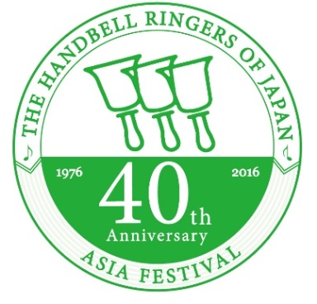**Handbell Ringers of Japan**

**40th Anniversary**

**Asia Festival**

The Handbell Ringers of Japan will be celebrating its 40th anniversary in November 2016.

This will also be the 2nd Asia Festival following the event held in Fukuoka at our 30th anniversary event.

As we are all aware, the Tohoku Area of Japan has suffered the tsunami and earthquake in 2011. We have chosen this venue to gather together ring for peace and hope for the earliest recovery.

Our theme for this event is ‘Ring the Future’. We hope that our past 40 years will be reflected to the future of handbell ringing throughout the world!

**Date:** August 18th to August 20th (3 days/2 nights)

**Venue:**  Sendai International Center (Convention Center)

Aobayama, Aoba-ku, Sendai, Miyagi Prefecture, JAPAN

　 5 min by subway / 7 min by taxi from Sendai Station

　 17 min to Sendai Station from Sendai Airport

1.5 hours on the Shinkansen (Bullet train) from Tokyo Station

**Program:**

* Final Concert (Aug 20th)/ Massed Ringing Rehearsals etc.
* Solo Concert – performance by attending handbell groups
* 40th Anniversary Ceremony and Reception
* Workshop
* Social Programs and Events, presentations, etc.

Schedule of Programs

|  |  |  |  |  |  |
| --- | --- | --- | --- | --- | --- |
| Day1 （8/18） | | Day2 （8/19） | | Day3 （8/20） | |
| 10AM  1PM  9PM | Registration/settings  Opening Ceremony  Massed Rehearsal  Workshop  Social Program  End of Day | 8:30AM  9PM | Massed Rehearsal  Solo Concerts  Group Rehearsals  Workshop  40th Ceremony  Reception  End of Day | 8:30AM  PM  17:30PM | Massed Rehearsal  Runthru  Final Concert  End of Festival |

**REGISTRATION**

25,000 yen per person (Japanese yen)

Group and Individual registration accepted

Group Leaders, Conductors and Chaperones will need to pay the full amount.

Registration Fee payment deadlines & schedules will be announced at a later date.

**Please register via your home guild.**

(HMA, HRGB, HGC, HSA, KHA, HAHK, HRSG)

If you are from a country without a home guild, please contact the HRJ directly for registration procedures.

**Registration Fee includes the following:**

* Access and participation to ALL events and venues of the program including group solo performance.
* Dinner for the 18th & 19th
* Lunch for the 19th and 20th.
* Workshop texts / materials

**Registration Fee DOES NOT include the following:**

Transportation to and from Sendai (including shipping of instruments)

Travel Insurance

Accommodation / Hotel Fees

Breakfast

Transportation to and from hotel to venue

Massed Ringing Music

Group Photo

**Hotel & Accommodation Estimates**

The estimates for the hotel rooms in the Sendai Area are as follows:

A type: 12,000 yen per person w/breakfast (twin room/two person use) – limited number

B type: 7,000 yen to 8,000 yen per person w/breakfast (single/twin room)

**Registration Schedule**

2016 October Registration Begins

2017 March Registration Deadline

**Post-festival RINGING TOUR**

There will be a 3 day post-festival Ringing Tour planned for the participants of the 40th Anniversary Festival. The tour will be a sightseeing tour of the Tohoku Area with a performance in the visiting areas as well as a CONCERT with the participating groups on the last day.

**Tour Itinerary (proposed)**

**August 20th**

18:30 Leave Sendai International Center

20:30 Arrive Ichinoseki / Hiraizumi Area (western style hotel)

Dinner included

**August 21st**

10:00 Sightseeing tour of Genbikyo / Chusonji temple (World Heritage)

Minami-Sanriku area (Japanese style Hotel – ONSEN - hot springs)

Breakfast, Lunch, Dinner included

**August 22nd**

9:00 Leave Minami-Sanriku area for Matsushima (World Heritage)

16:30 Arrive Oyama city – social event

Breakfast, Lunch, Dinner included

**August 23rd**

All day Rehearsal and preparation for CONCERT at Hakuo University

Breakfast included

21:30 arrive Tokyo station

**Cost per person: 58,000 yen**

*This is the maximum price – may change in accordance to participation.

The price includes ALL transportation (via chartered bus) from Sendai to Tokyo.

The price includes transport of all instruments including foam.

Further details will be announced shortly